Chapter 14, Solution 66.

- Proof

- When 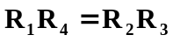,
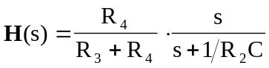

- When 
